BRAIN BASHERS ANSWERS

1

L | A | S | T
E | V | E | R
A | X | L | E
F | I | V | E

2
Start from the top left dot, and go past the top right dot, and then diagonally down to the bottom left dot, back up to the top left dot, and diagonally down to the bottom right dot.
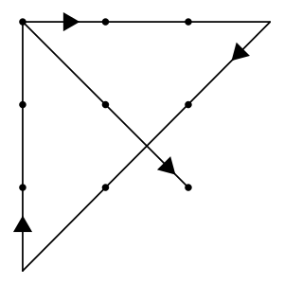

3
Answer
Seat 1 Peter
Seat 2 Lia
Seat 3 Kenny
Seat 4 Jennie
Seat 5 Harvey
Seat 6 Joyce
Seat 7 Rick
Seat 8 Mark
Reasoning
Jennie is in Seat 4 and next to Harvey (Clue 6), so Harvey is in Seat 3 or Seat 5.
Harvey has a higher seat number than Jennie (Clue 1), so Harvey is in Seat 5.
Peter is across from Harvey (Clue 2), so is in Seat 1.
Peter is next to Lia (Clue 7), so Lia is in Seat 8 or Seat 2. But Lia is not in Seat 8 (Clue 3), therefore Lia is in Seat 2.
Lia is next to Kenny (Clue 5), therefore Kenny must be in Seat 3.
Rick is across from Kenny (Clue 4), so must be in Seat 7.
Joyce is next to Rick (Clue 4), but not in Seat 8 (Clue 3), so Joyce must be in Seat 6.
The last remaining seat (Seat 8) is occupied by Mark (Clue 8).

4
Answer
£50.
Reasoning
Working backwards:
On Thursday, I had £12.50.
On Wednesday, I had £12.50 x (1 ÷ one half) = £25.
On Tuesday, I had £25 x (1 ÷ two thirds) = £37.50.
On Monday, I had £37.50 x (1 ÷ three quarters) = £50.

